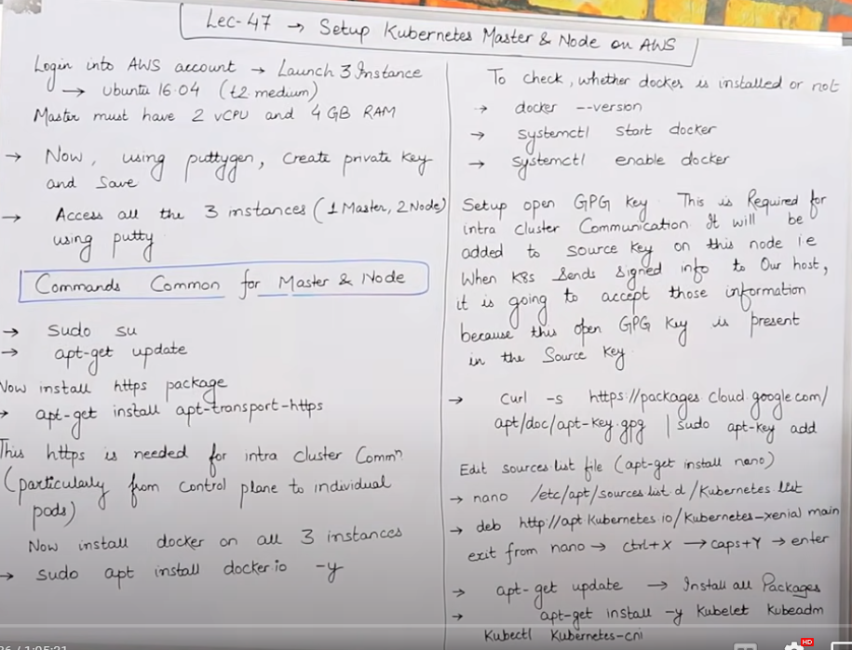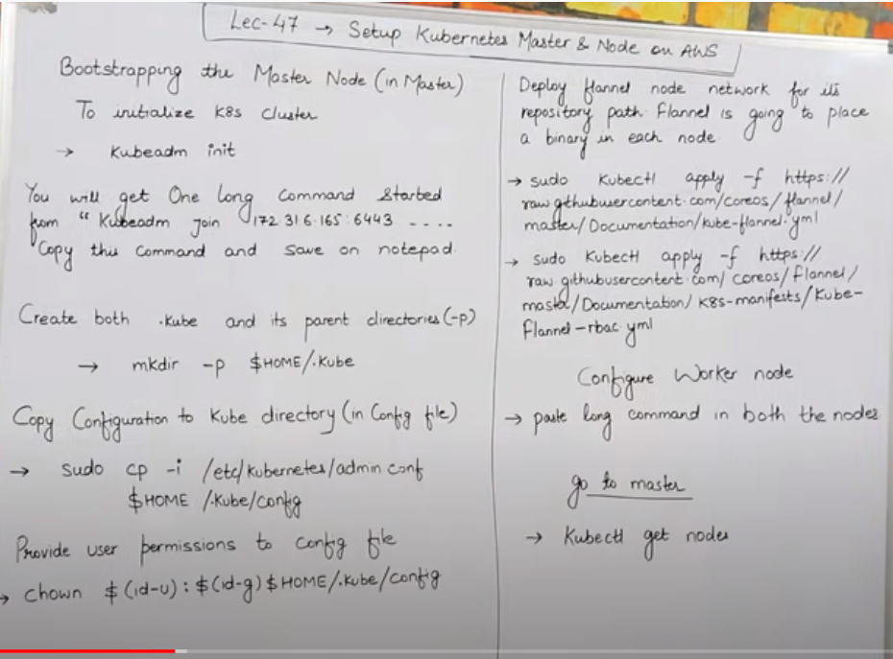

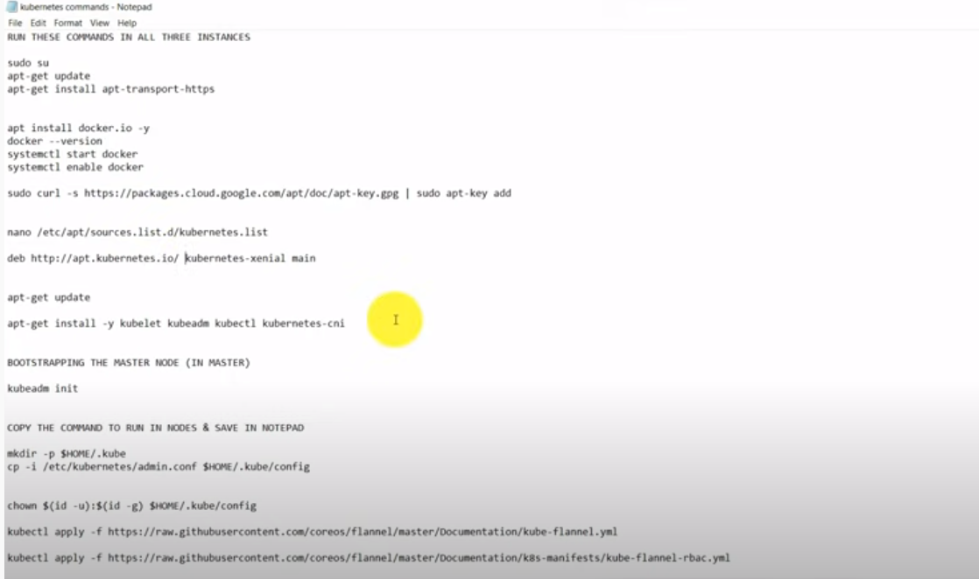

Master: t2.medium ( 2 CPU and 4 RAM)

For Ubuntu, the user name is Ubuntu

for gpg key: its required for authenticating the nodes for cluster communication. This key present at master and all worker. When master communicates to worker and vice versa then by seeing the GPG key they will identify each other.

|  |
| --- |
|  |
| sudo su  apt-get update  apt-get install apt-transport-https  apt install docker.io -y  docker --version  systemctl start docker  systemctl enable docker  sudo curl -s https://packages.cloud.google.com/apt... | sudo apt-key add  # sudo curl -s https://packages.cloud.google.com/apt/doc/apt-key gpg | sudo apt-key add  nano /etc/apt/sources.list.d/kubernetes.list  deb http://apt.kubernetes.io/ kubernetes-xenial main  # Above will create the file and add the line no 16, it will download the package kubernetes-xenial  apt-get update  apt-get install -y kubelet kubeadm kubectl kubernetes-cni  BOOTSTRAPPING THE MASTER NODE (IN MASTER)  kubeadm init    COPY THE COMMAND TO RUN IN NODES & SAVE IN NOTEPAD  mkdir -p $HOME/.kube  cp -i /etc/kubernetes/admin.conf $HOME/.kube/config  chown $(id -u):$(id -g) $HOME/.kube/config  kubectl apply -f https://raw.githubusercontent.com/cor...  # kubectl apply -f https://raw.githubusercontent.com/coreos/flannel/master/Documentation/kube-flannel.yml  kubectl apply -f https://raw.githubusercontent.com/cor...  # kubectl apply -f https://raw.githubusercontent.com/coreos/flannel/master/Documentation/k8s-manifests/kube-flannel-rbac.yml  CONFIGURE WORKER NODES (IN NODES)  COPY LONG CODE PROVIDED MY MASTER IN NODE NOW LIKE CODE GIVEN BELOW  e.g- kubeadm join 172.31.6.165:6443 --token kl9fhu.co2n90v3rxtqllrs --discovery-token-ca-cert-hash sha256:b0f8003d23dbf445e0132a53d7aa1922bdef8d553d9eca06e65c928322b3e7c0  GO TO MASTER AND RUN THIS COMMAND  kubectl get nodes  ***********************END************************************* |